1. PPO Model Training
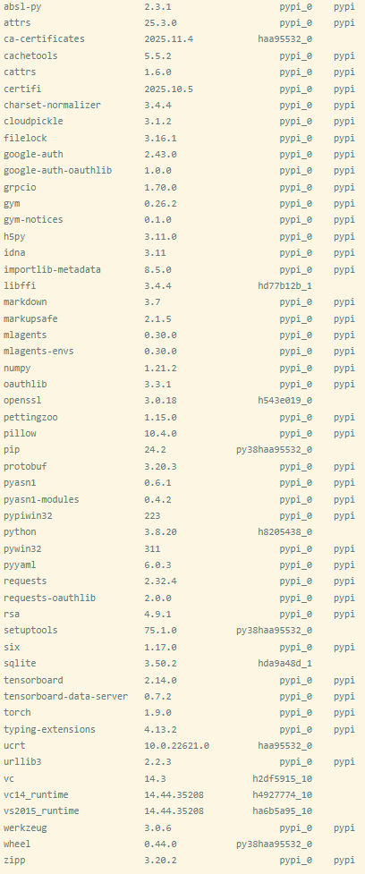
(1) Anaconda Prompt Environment Configuration

(2) ML-Agent Server Startup Command
mlagents-learn "***\Assets\ML-Agents\Configs\shooting_V2.yaml" --run-id=ShootingAgent_Trajectory --force --time-scale=20
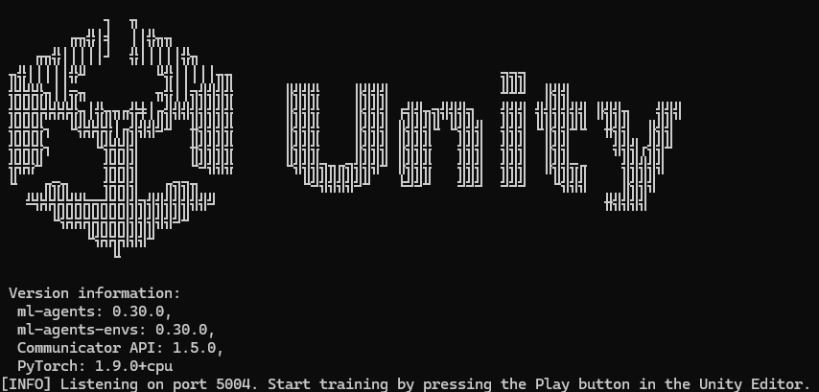
(3) Starting Unity Client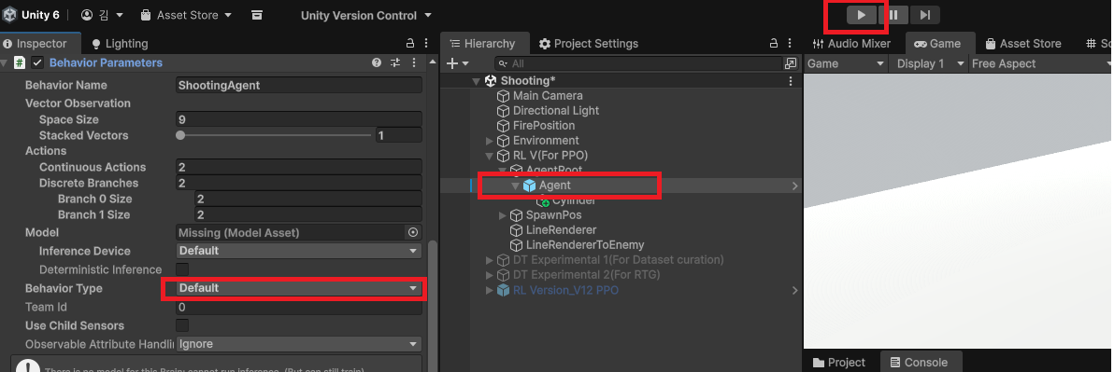
After activating the RL V(For PPO) object, if you click the Unity Play button, training starts for the number of times specified in shooting_V2.yaml. All logs are generated as a “trajectory_log.json” file in the Persistent Data Path folder.

2. DT Model Generation and Training
(1) Open DicisionTransformer.ipynb and execute the cells in sequential order.!pip
> uninstall -y torch torchvision torchaudio
> pip install torch torchvision torchaudio --index-url ttps://download.pytorch.org/whl/cu124
*convert_to_pickle.py
Converts “trajectory_log.json” into “*.pkl” files, which are easier to use for training, through a series of steps. (2) 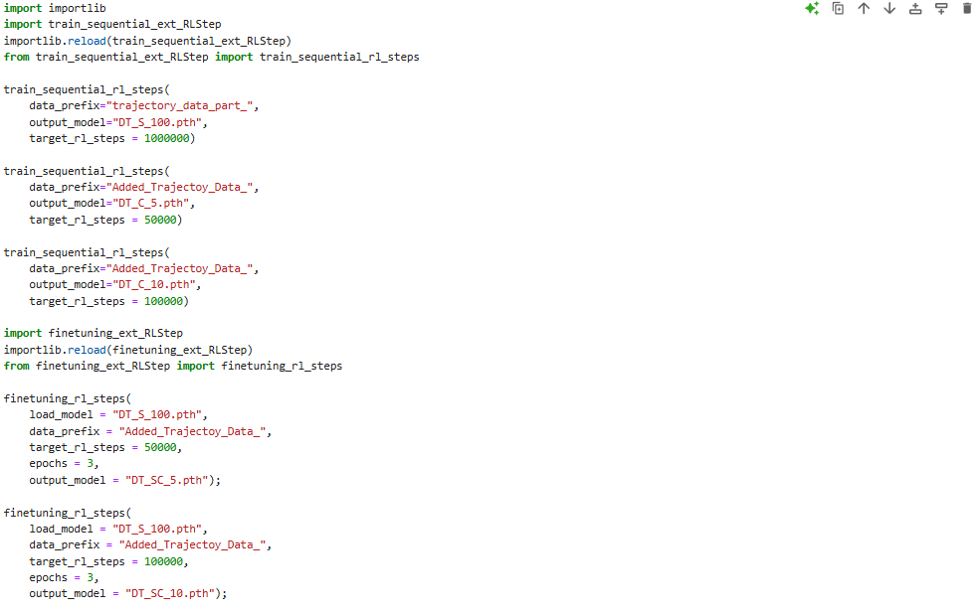
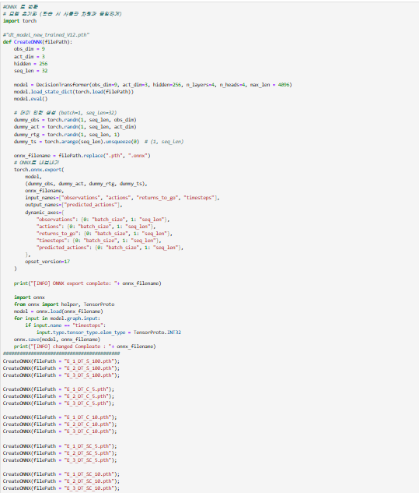
[Caution] The cells at the bottom of the image above are test codes. You must not execute them.

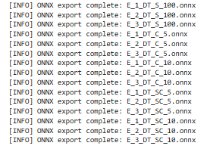
*Convert to ONNX (Code Block for ONNX Conversion)
3. Deriving Results
1)PPO
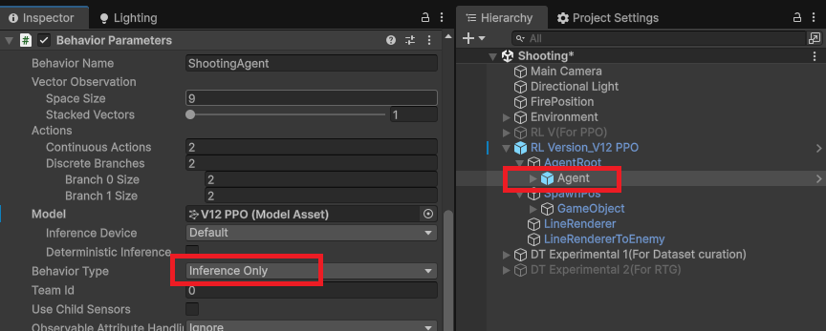
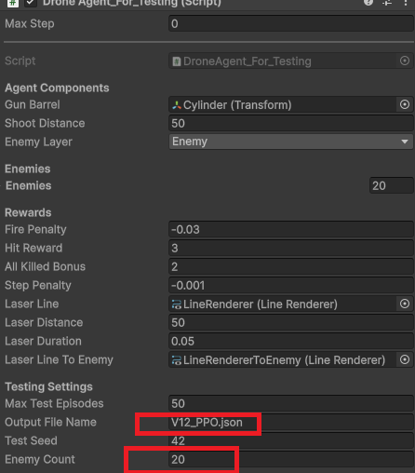
PPO After configuring as shown in the image above, change the EnemyCount in the image below to (10, 15, 20) and click the Play button.
2) DTModels
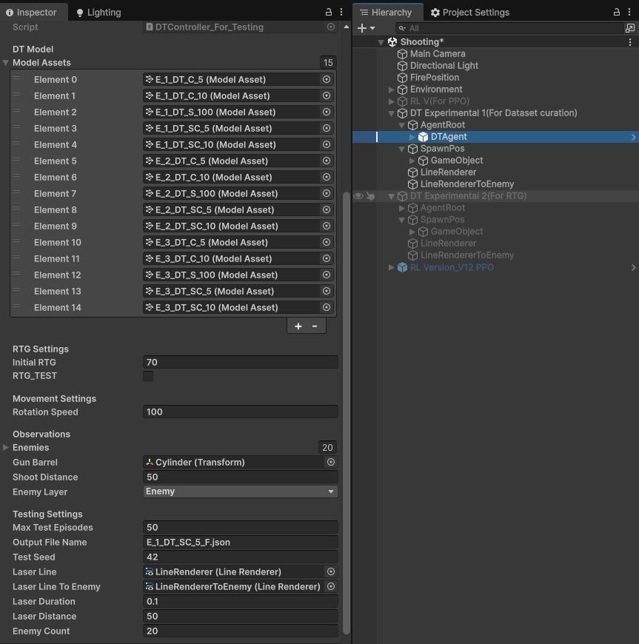
After configuring as shown in the image above, change the EnemyCount in the image below to (10, 15, 20) and click the Play button.

