Devious masked Ones [!]

This is now a DmO Item DataBase
If You are looking for an item and don”t see it here feel free to Request an item
And kik HeartlessFr0sty an picture of the item or Psn Message Heartlessfrosty
DmO webSite coming soon Freeze list will start on this page suggestion any user IDs to put on here wish so that i can add them onto the freeze list
NOTE: Please Wear DmO at all times so that i can know if its safe to share or say things to you and to also get known for DmO to be CFW Club. Warn Other DmO members if your going to Freeze an server!

[!]DmO”s FREEZE LIST [!]

Drew
vRezurrection

Ninja pants Male
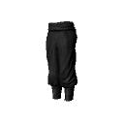
Item CODE: D42E32DB-50444660-8EFEE128-07991F55

Ninja torso Male
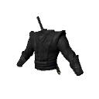
Item CODE: CD9C8FEE-25F04987-87631433-D6F65593

Red suit Male
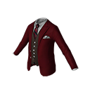
Item CODE: A3DD5723-226D4966-9AE11DBD-B5E79493

Blue sweater Male
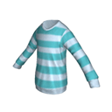
Item CODE: 265AA4CB-AAC94870-91EB8D29-4E1EC869
Red sweater Male
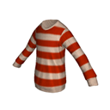
Item CODE: 4A01BBFA-070E4E9D-B45FD65B-AB4FD831
Coffin Male
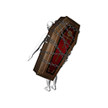
Item CODE: B63A787B-CD76481B-A40AB0F4-03BEC947

Frosty Male
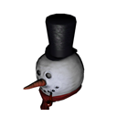
Item CODE: E5891AAD-9D424EB1-A13C3E59-66D7CADF

Mod old t-shirt Male
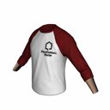
Item CODE: 562BA430-CFE64919-A7FFC955-91DC4C09
Vega mask Male

Item CODE: 44437822-980E4980-81605D50-50422658

Black mask Male

Item CODE: F21DDD5C-0FE148E4-995A0FE2-C6BA190D

Purple suit Male
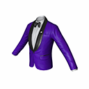
Item CODE: 477C6962-D7094347-911C7E74-06B3847E

Blue suit Male
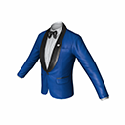
Item CODE: 68CE28CC-30044151-A540E545-06EAF54C
Orange striped Male
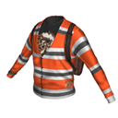
Item CODE: 2477DD64-BC6D481F-9FA5A51B-9ACD1E4B

Red suit Male
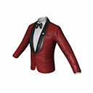
Item CODE: F680122A-A2AE4D47-A0389B3A-8646650C

White suit Male
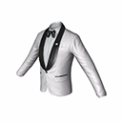
Item CODE: D3EC3849-C0FE42AF-B5083CCA-37ED1219

White t-shirt with jacket? Male
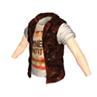
Item CODE: 0E4F78B8-86774895-95A3B0DD-69CC56DF
Purple sweater Male
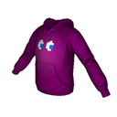
Item CODE: 95984057-254D40E4-966AE895-0805C8EF

M

Item CODE: A1559AFA-7BE747CB-A214F43D-129C4288

M
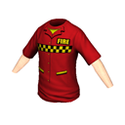
Item CODE: 00F6221D-9751407A-8102BC12-0E2044BE

M
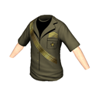
Item CODE: 424D39C0-97B549C6-AD123028-8DB597FA

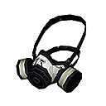F
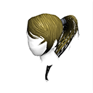
Item CODE: 579736D8-AA104A85-851641AC-761F92AA

F
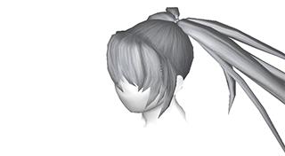
Item CODE: 0B952C67-B86640C3-A677D07C-673820BE

White Gasmask Male

Item CODE:
C5E5D1FE-B28D4D08-AA3488EF-04B077C4
Pink JP haie Female

Item CODE: 156F531D-0EBE4393-ABFF94C8-4D8DC0A4

BRS hair Female
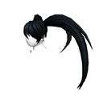
Item CODE: 1ECF3F4D-EB7A4EA9-86EE6707-8C2F5936

White Jacket Male
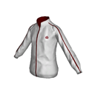
Item CODE: AAD975C8-322544B6-86E0CD3D-E235B664

Miku hair Female

Item CODE: 422C0073-3E5347E7-95E123DF-FB0F0DF4

Guide jacket Male
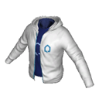
Item CODE: FC440FFD-9D544890-A58C9282-24812C20

Reaper head Male
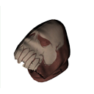
Item CODE: D794F83B-5F684A81-A7694FE4-FF7225BE

Reaper torso Male
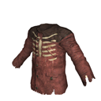
Item CODE: A7BE2106-551D4DDF-A9E58C35-75E7E5C6

Reaper feet Male
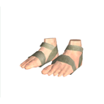
Item CODE: DF5C3F13-D2B04415-9A82C675-511C0E83

Green jacket Male
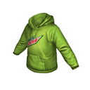
Item CODE: 1AB5AFF7-AB5E4D7D-82C64704-9D731A8F
Black suit Male
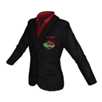
Item CODE: E8E25DE0-CBC0497B-8891493B-B6DBE890

M

Item CODE: 85F8ADB8-2E284547-86EA0BFD-02B398BA

Pink pajamas Male

Item CODE: 32400A4B-4793474A-AC5846C4-FA529C39

Poker hat Male

Item CODE: 94C7F83E-47274823-BFA69884-28295E0A

Yellow bow
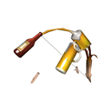
Item CODE: CC8BE783-E2D84994-B451646E-7EE2086E

Black book Male
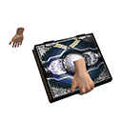
Item CODE: 84207C1E-33644A1F-B8AF1668-9CB938E2

Purple sword Male
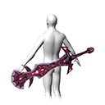
Item CODE: 7FCA2C85-25F34C56-BC427EEC-C39DBF03

Purple two swords Male
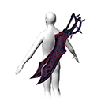
Item CODE: FEFFA904-13AD498F-9F54D06F-FBF2EF81

Red and blue swords Male
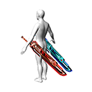
Item CODE: 400D7158-BBDF46EA-BFA124C7-24BAE4EA

Blue tail Male
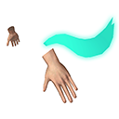
Item CODE: 9F9D52BD-E44B4163-9C19812A-C2102D5E

Red sword Male
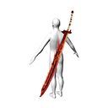
Item CODE: 4FD5A2BA-FCC34D9B-B3287459-7BFF9E3F

Blue sword Male
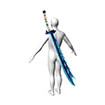
Item CODE: 4FA498CE-3EFC44BC-9A602CBA-054AA7F5

Pink dress Female
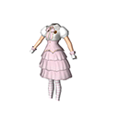
Item CODE: 03C7B062-61B0499E-9D032CDF-FE1C8826

Long grey jacket Female
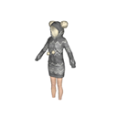
Item CODE: E58F409D-32A44EF1-9BCEB9D1-52C11CCF

Brown Bunny Female
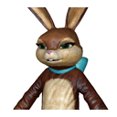
Item CODE: F96D095D-1B374AE5-9E46E154-7E47375B

Blue dress Female
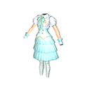
Item CODE: EA4C10B6-A3B347AE-B64622E2-D64305CA

Long grey jacket Male
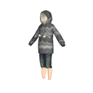
Item CODE: F94A5F3B-5E464A45-B5E105C7-57589313

Panda lollipop Male

Item CODE: ADF4F4FB-2C8B43E2-A7A3C6EA-795F11C3
Pink lollipop Male

Item CODE: 94F2FE02-F5434823-9557947BA-52F00F3A

Red Flaming head Male

Item CODE: 76D0CDD6-16B54C8F-BE766217-DE389FC5

Snowman Male

Item CODE: 0AFCE59D-B9D64EEC-B4C54D89-EB74752A

M
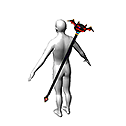
Item CODE: 081D6CB2-16D54CD6-863A22B6-CBEF6E25

Pink bikini Female
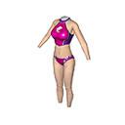
Item CODE: C41943DA-6C104035-9E1FE121-05DC0AF1

Bunny Pink dress Female
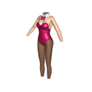
Item CODE: 037E26E3-3D5D4EF8-BF4E4FA9-E6FD129C

BRS weapon Female
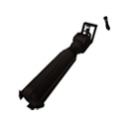
Item CODE: 7110C26C-72574EFE-A20044ED-679CC79B

Jeans Female
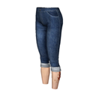
Item CODE: 3EFC1404-FD7D4505-8B089BB6-BBF4247C

Black dress Female
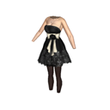
Item CODE
: 7584CF6E-C9DB43B9-B4461E71-0A73FACA

Pink long jacket Female
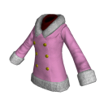
Item CODE: 5241DAC0-0AFC4960-A28ABD7B-23C89970

Blue long jacket Female
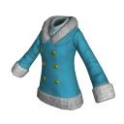
Item CODE: AA64E7C9-B27C4766-BB050BA7-39654B8D

Red long jacket Female
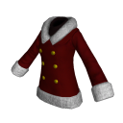
Item CODE: 58AA6602-4B84446B-A68C1DFD-875314BD

Bubble Male
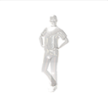
Item CODE: 79EA58AB-861A49DE-A19C9133-CD6F0DA0
Blue ears Male

Item CODE: D840FD0F-B4944293-B337202C-862A59BF

Blue anime hair Male

Item CODE: A0167892-FC1348CA-9C3044F9-BCF841CB

F
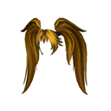
Item CODE: DAE2F5C1-E8A141CC-8863C83B-0CC99D72

Black ops Male
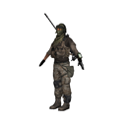
Item CODE: 2628F9A5-4E894DAD-91886BDF-04A05229

Kickass Male
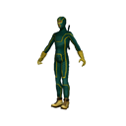
Item CODE: 024B7DA9-CC2B45CA-A0DCD8B1-ECE3B71A

Alien Male
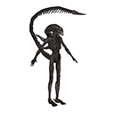
Item CODE: B83580DD-C154438F-A51E6F52-05EC2DFF

Ironman MAle
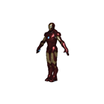
Item CODE: 73B4773D-1F6E4D57-93669AA1-368D9BF0

Kickass Female
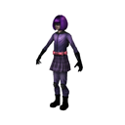
Item CODE: 75B3759F-6E404BF6-A20B0818-9DE0035B
F

Item CODE: 51A16AA6-AF4F45AB-82117F1A-BC9BB02C

F

Item CODE: 897CF008-66984046-B8EFE557-23ECE399

F

Item CODE: EA0C2F9D-268C47C5-BC451F98-5C8FED74

F

Item CODE: 82B907C7-A48642F9-A4745E95-7376B3B5

Frosty Female

Item CODE: 5FE1FA90-099C483A-A8C96894-8B77EAF1

PsMove Male
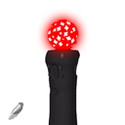
Item CODE: D5E0E085-1EC349D5-BBF269E1-8637733C

Orange outfit Male

Item CODE: BAA83ED5-F78E4198-A917B142-267D067D

M
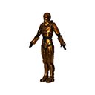
Item CODE: 84F4CAD5-7C8B40F7-9509D3F7-DB922696

Black bunny Male
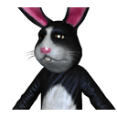
Item CODE: 94E02D8F-F3A84CF6-A5CCE776-97B40471

Grey Bunny Male
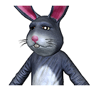
Item CODE: B7215E15-E24948A8-AB8022A0-4299F4D7

Dinosaurs Outfit Male
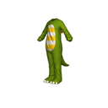
Item CODE: 64FC0CF5-DEE14B7C-889E89DC-548524B7

Green Snake Male
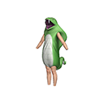
Item CODE: 2148318F-C4294591-B8A34A63-65328ED6

M
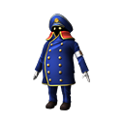
Item CODE: 9FE4E49D-77694965-AB7C03AA-17E600ED

Green long jacket Male
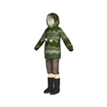
Item CODE: 93F0BF7A-B2F14251-A15E7E9B-31584777

M
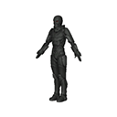
Item CODE: F150B697-6F774CBA-96CE966B-281975FC

M
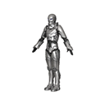
Item CODE: 67CB2793-5EBF43D3-9B72C3D6-8C0F1122

M
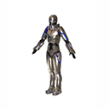
Item CODE: F002AED3-18154345-80F27534-4880EBFB

Grey full suit Male
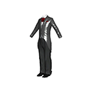
Item CODE: FA6706C2-F18D4D27-A61C9814-C986C1DC

Black full suit Male
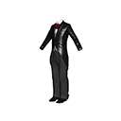
Item CODE: D4D22D78-DF794E1F-B4C6D9BC-FFA21254

Yellow fulls uit Male
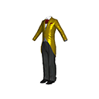
Item CODE: 0FB1812D-D0CC464A-A2906550-32755060

M
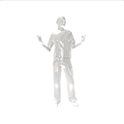
Item CODE: CCA16588-F5BE40D8-BE852A81-EA442201

M
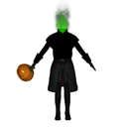
Item CODE: B2058B07-9AAC47C5-9AB4FA2E-FF0FCC9D

M
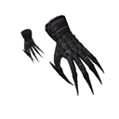
Item CODE: 0347F779-7D7F4F45-8F40C9A6-154ADB13

BBQ Male
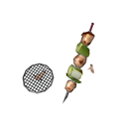
Item CODE: 73288F24-83F84DCA-9326DF42-567CBF67

Male Drums
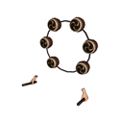
Item CODE: 2AAB3316-678C4183-BFC6D2B7-C17F8CB9

Red two swords Male
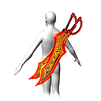
Item CODE: 88A6B694-B7A040CC-BBF478A4-43F33B5F

Green two swords Male
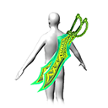
Item CODE: 7509D69E-CF24409A-B3E30553-B7045B7D

Purple two swords Male
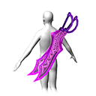
Item CODE: 70B2390A-BD3344A3-924B4B37-E6AA8309

Blue two swords Male
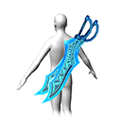
Item CODE: E623DB82-AD5A4B65-9FC11C37-93407FC3

Yellow two swords Male
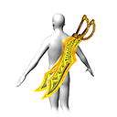
Item CODE: E5D6AE86-627D44AA-AD39EA12-939FEF57

Bronze two swords Male
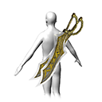
Item CODE: 01C76CDA-74474DFA-A8A94E5A-A3759D76

Dinosaurs hands Male

Item CODE: 0CE44898-D0604A01-A7526959-0627C0B5

Purple devil Male

Item CODE: FF6BDDBE-7F4D40C3-AADF79ED-CF6F715B ;-;

Male Cat in hands
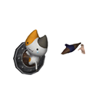
Item CODE: 877BF574-A6E9429D-9DA9562C-9BC40395

Hammar Male
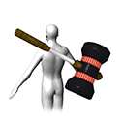
Item CODE: 9DAAB030-5C2A487F-AD2A9558-428E4ACB

Red Reaper sword Male
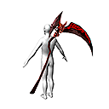
Item CODE: D43005A6-86D349C0-92D9E370-3771CDCB

Red book Male
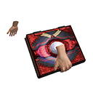
Item CODE: 84392601-1E9B45AC-9CFE4704-4A8549F4

Yellow book Male
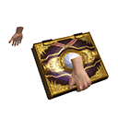
Item CODE: B2E140FD-FE3A4777-B7097D3A-E0A35BB1

Purple book Male
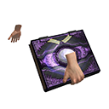
Item CODE: 833D8B2A-3E254D93-BBC2A0AD-213DDECB

Blue book Male
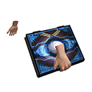
Item CODE: C887F4F1-778C41B2-9F859B6E-31CD3FEB

Green book Male
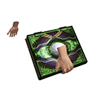
Item CODE: 012AEBC2-ADE94B66-93B9A5C1-15B3E625

Panda Male
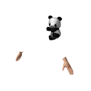
Item CODE: DAB42D5C-2D99440A-9140E7C5-52408CE7

Male 2 swords
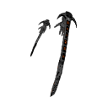
Item CODE: B77049C8-0C35452A-95B7ECC4-01320D1F

Male penguin

Item CODE: BC752DC6-D2044B83-A86C680E-B59B06EB

M
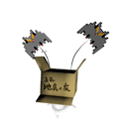
Item CODE: C165A7FC-A0494061-B67C8C90-B7F6360B

M

Item CODE: B7158C1F-0CDF4A5C-B79A4527-F461250C

Dinosaurs Head Male

Item CODE: C29A1A68-1A6941EF-B5C9B9FE-0F56ED48

BRS Outfit Female
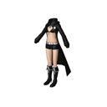
Item CODE: 88CA8130-143140D0-8D7819D8-5684380B

Female WRS outfit
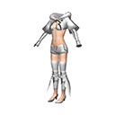
Item CODE: 85A2EB7E-27194D67-AB06BDD9-2CA35EFA

Reaper pants Male
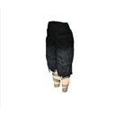
Item CODE: 9CDCD5E1-1DF4488D-B964E4EB-83E8A70C

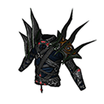M

Item CODE: E115C863-D3F040F8-81FF1A01-D86C6D07
R

Big Dinosaurs Male
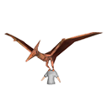
Item CODE: 4065CB87-566648D0-8A347F3C-3EAB6944

Green jacket Male
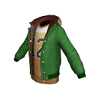
Item CODE: B82E5EB4-B3B84AD7-9D44EAC8-367087F0

Blue boxing Male
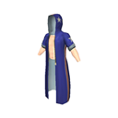
Item CODE: A4480EEA-AB354D5D-BF77AFEB-643CB1A2

White jacket Male
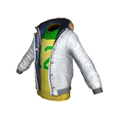
Item CODE: E6E8B98B-7D79459D-8947BAE8-89A3D43C

Black coat Male
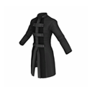
Item CODE: 3890671C-185A49D0-AF28F11B-8F5F31D4

Two faced joker Male
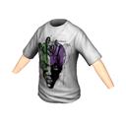
Item CODE: AFE8722A-162749AC-90D272D7-885B7CEB

Batman jacket Male
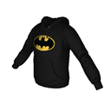
Item CODE: E4557072-B59C4627-8019B6D0-93B0777F

M
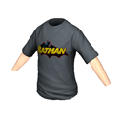
Item CODE: B0277227-DC314A88-A5C4B439-65F5DAF3

M
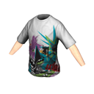
Item CODE: 152C8235-E38B46A3-9B2138AF-5553692E

Batman t-shirt Male
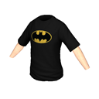
Item CODE: 62848894-905649CA-9C7638CC-9603703D

M
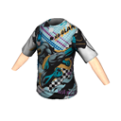
Item CODE: 811B510C-C7734369-A3D145F9-0A78A281

M
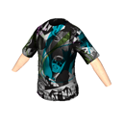
Item CODE: 8852924A-88C748C7-885312C4-DC379197

M
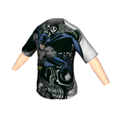
Item CODE: A5B5B6B0-B98546D9-8CE47E9A-88D39E20

M
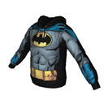
Item CODE: CEF43EEE-EB7B4D67-871897B7-0FD06B89

Joker t-shirt Male
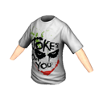
Item CODE: 15DAB6B3-60FA4F17-B2B0FA03-6EBCDB0A

M
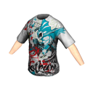
Item CODE: 7CE9FC2E-13C948BF-B4851BFC-8C0CFB6A

M
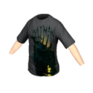
Item CODE: FB7ABBA7-AA8D4AD8-B068B4F4-3F0E5A3E

Batman Yellow t-shirt Male
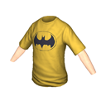
Item CODE: 243D495C-45C342AF-ACE2EB67-05EC907D

M
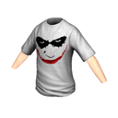
Item CODE: A64CA1D0-B43242D3-BE5BDEE0-A69403D3

M
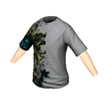
Item CODE: 7F55FAC7-6650403E-B7D90FFD-AD3BE48F

M
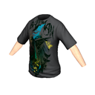
Item CODE: 914BCEA7-89644B45-AD9606F1-D33391CA

Brown ears Female

Item CODE: EC443CB4-7D7247DB-A77256D6-25C02949

Red blue flowers Male

Item CODE: 85A15A38-A9024A9B-9949A583-E8252775


Item CODE: 27C98318-4CA14F5D-B5721223-12BC7240

Red Gasmask Male
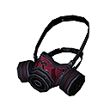
Item CODE: C8550125-44824BA6-8586CE2E-7A1E0F98

Green Gasmask Male
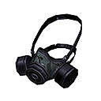
Item CODE: D5924483-703D4707-8DE82EC6-4D4D1336
45A36DA7-F502415A-A617FFC4-D319623B - gas mask female black
82107696-BB4B40E7-8ADB7E99-C560FBE8 - gas mask female red
9408809B-C7FF4340-A757973D-3EB2DABD - gas mask female green

Salary Male
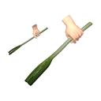
item CODE: D75A62EB-FA6E4466-967B135B-B6038145

Female celery sticks
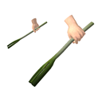
Item CODE: 2008A1C2-4BCC4DA8-A238DEC0-391DDB20

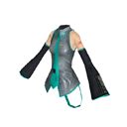-
Item CODE: F792BB07-836C4A1B-B7687172-90B8580C

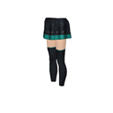
Item CODE: 07029742-01454F61-B2F2E605-52D46742

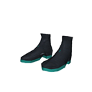
Item CODE: 9506F909-E9BC4C46-BEA3CA9B-592FE908

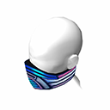
Item CODE: 027B02AC-100D4819-BC616E7D-BA35C3AB

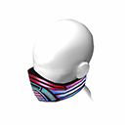
Item CODE: AACAA22B-50F64856-A39FD452-7B5E58A2

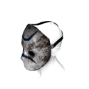
Item CODE: A5289C0A-78944CA8-89852E32-E3BB37C3

Poker champ male

Item CODE: 6CCBC2A7-4FD64E9A-AF68FFBD-17621DE1


Item CODE: 0204FE4B-A726430C-9C9F0F36-40A40081


Item CODE: 52E21A78-36A0449B-9F953004-EE17D013

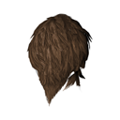
Item CODE: 51404513-97BD4205-A08CF3AB-A4BB9DCF

Item CODE: 48CE4C0B-CE874C44-91A78D69-931C1514



Item CODE: 09274E6B-B9044255-9916DB00-ED4840B0


Item CODE: B0ED6BC3-55B24CD1-97F15876-3381C36C

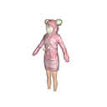
Item CODE: 343025BD-93CF4951-8B5F648F-A82E06DF

Cat Fan (female)

Item CODE: 9AE37C0D-EAEB451F-B3CE7EF3-4437B500


Item CODE: 36F142A6-B9C14FFE-9FAC24BA-BB02609A

Female Teddy bear (hands)
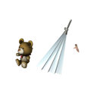
Item CODE: 6407B922-6CBF414F-85106F2E-73DBC49F

Female Heart hand
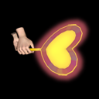
Item CODE: 9A9EA1FF-DAFB4384-8D7052DA-E2479038

Female Cat hands & Tail
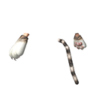
Item CODE: CF35D185-339B4520-A79BFDA2-15A8BC98A2-15A8BC98


Item CODE: C7B38B2C-5FF14BE0-AE3C4AD4-6E12DECF

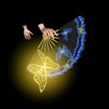
Item CODE: 8EF0E4FF-441B4312-B477710E-C725F72B


Item CODE: 74A78C2F-540F4533-89987833-9ED584FC

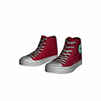
Item CODE: 89831207-2088495A-85CEE5F0-34CC0D9C

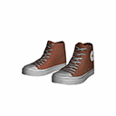
Item CODE: CE093B79-CDE048A2-8DE3E92F-3440DF44

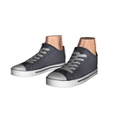
Item CODE: CCD7D2C1-58484E78-BD9F3703-EADEC9FF

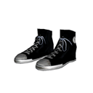
Item CODE: 7913819B-18FA4156-96A979E1-0720D956

Male IREM Boots (Mh)
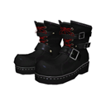
Item CODE: 4E0EEFF8-C5854291-A2513E5E-C70BC62A

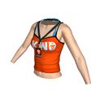

Item CODE: E2BBDF03-A14F4806-88110D1B-3AC8A3C2

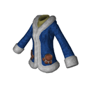
Item CODE: 77D43FF7-49B8481B-B53DC512-A74B25DB

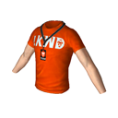
Item CODE: 8D7EB528-302949C4-85AC36B0-67F56F3E

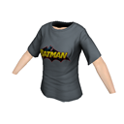
Item CODE: A0054BE8-FB1D49F5-A733F77D-E6BB2BBC

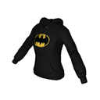
Item CODE: CB6550A6-429C463D-B167D860-72455C38

Item CODE: C6075823-4CD14054-BA78DA99-01438D38

Male {Bells on head}
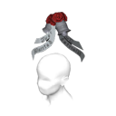
- 63724660-A1424513-B6F62880-DF2A8225

Male

- 52765D24-6AF347B3-8E18E367-F363AA6B /M

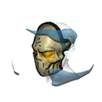
Item CODE 5BF50AE0-067F4879-9D3A4192-CC5951A0

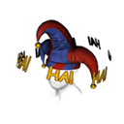
Item CODE 041AE986-48A54B5B-80B0CF38-72DF892A

Item CODE 19279011-B7344EF9-A1C9C285-7D806A6F

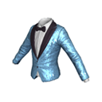
Item CODE:1E6D0D82-DB8C48B2-85FCA4C4-D58A3AA1

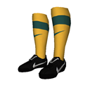
Item CODE: F25D3826-F8B1425E-81665BF4-E8600F91

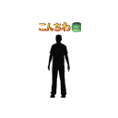
Item CODE: | 1E6B83EC-B79641AF-99066F09-3884351C
Item TYPE: | Locomotion
Item GENDER: | N/A  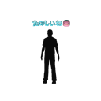
  Item D:D88AC6B6-B5E4436E-B9B8BF15-C9EB0542
  Item TYPE: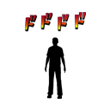0CA44A5E-F04E490C-A83C7316-2CEDC8F0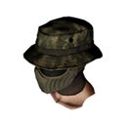  1A143822-E279411B-AB4898D5-F459AD60  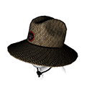  C 3 C1396AC0-3C6D485F-AF182623-7C87D3D5    4 4C2D4C20-968F4CD7-87F376A2-35290B7F  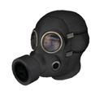  D D85ED908-6645440E-811B20E7-8ADDFAEA    6 648C566D-4DEE4B5C-B5611125-02895FE6    C CC1D00B3-94E9499B-971CC4CF-8CB5E758  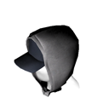  9 940BC678-6A5E4194-9775EDF2-18DC4B46    A A1376F27-F5B1402A-99A5684B-01252103  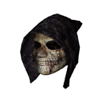  2 249C32DF-520A43B7-A3F2A432-7A1FB319  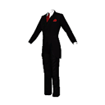  0 0F6D2F3D-304F408C-A98B5D1F-8C72449C  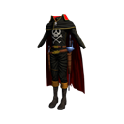  9 911B8730-FD134A26-991C12CB-C3742A17  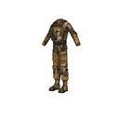  6 67D4D023-4ADF4A3A-B6F0452B-626080FFF  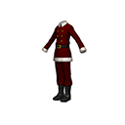  9 90CCCA8B-21AB4331-B2DF5A75-F2  9799C  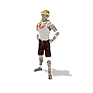  2 24225D62-8FAD4E53-B6EAAE20-860B73F4  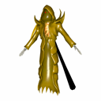  621304CC-DD084CB7-97891E7B-B4D3B73A  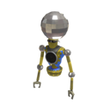  8 8AAAB490-EFF247E3-B557F55C-FCB14AF2    839C95FE-F3074A62-8DB795FB-6306EB2D    16B61BE3-3A614235-83D7F44C-E32C18F6  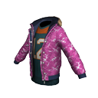  EF85C87E-89C14D71-88AF83BC-6F891513  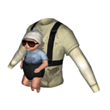  18E27829-BE964BF8-96194D40-56D26B92  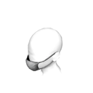  69BEF9DF-9D8F49B3-8ED66DF3-A3349F93  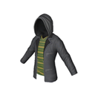  7A4C888C-28A24B7B-B24A41C0-37BC9CDB  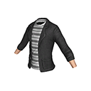6867A2A6-631344D3-B7FABE04-52393FBB  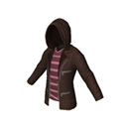E1702614-52884E60-B7C13D98-2AD566E5  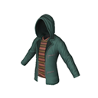18512ADE-2A8F4453-92BFA282-ECE7326B  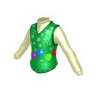B1089A9A-884641DD-A2CE0D14-68B762E8  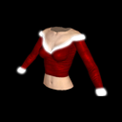27341302-60E34808-9A464A8E-A475D93F  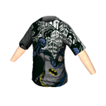AF4549E2-E5324BDE-8B647F6E-5086AB62  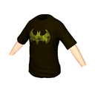E5372730-628C41BC-88599F34-FFBEACFB  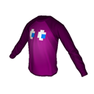9E632166-05FF4EDB-947F187C-A7ED2E12  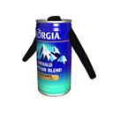AF5ADC5D-2D864098-A5FB510C-6F86A2E3  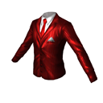01EB428B-05A8476E-94AFC6CF-C4250299  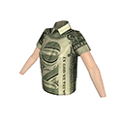14B7D2DB-D215455D-9D9A5549-6F2B5DFE  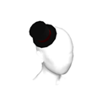9CAA8FBF-6AD8416B-B2D704B3-8F676C4F  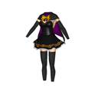673F9597-DEC447A8-91672E7F-A45F9F39  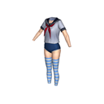6013F50F-3A9A401C-997F5EB2-C51E8225  43FDAA6A-B4E844F0-9318D66C-C3D52A10  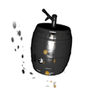89467CC0-70BE404C-9C3EDA24-051000F4  64D4025F-5715453B-81D4E0F1-3F4E947E  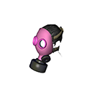FA4A9C63-849B48CB-A36BD275-ADBB2EAD  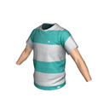E668141A-5A6D4C25-AE019EFF-F3AA7B00  Male Money shirt - 50E9F6EE-4AA04AC7-8683F575-5E2350AE    4417B809-352B41A0-98994A - item needs FULL code!  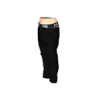E0AEACBD-81B64DFA-AC8144EB-14E87D7B  <REWARDS VERSION="1">  <REWARDTICKET><OBJECTID><REWARDS VERSION="1"></OBJECTID></REWARDTICKET>  <REWARDTICKET><OBJECTID><REWARDTICKET><OBJECTID><REWARDS VERSION="1"></OBJECTID></REWARDTICKET></OBJECTID></REWARDTICKET>  <REWARDTICKET><OBJECTID><REWARDTICKET><OBJECTID><REWARDTICKET><OBJECTID><REWARDS VERSION="1"></OBJECTID></REWARDTICKET></OBJECTID></REWARDTICKET></OBJECTID></REWARDTICKET>  <REWARDTICKET><OBJECTID><REWARDTICKET><OBJECTID><REWARDTICKET><OBJECTID><REWARDTICKET><OBJECTID><REWARDS VERSION="1"></OBJECTID></REWARDTICKET></OBJECTID></REWARDTICKET></OBJECTID></REWARDTICKET></OBJECTID></REWARDTICKET>  <REWARDTICKET><OBJECTID><REWARDTICKET><OBJECTID><REWARDTICKET><OBJECTID><REWARDTICKET><OBJECTID><REWARDTICKET><OBJECTID><REWARDS VERSION="1"></OBJECTID></REWARDTICKET></OBJECTID></REWARDTICKET></OBJECTID></REWARDTICKET></OBJECTID></REWARDTICKET></OBJECTID></REWARDTICKET>  <REWARDTICKET><OBJECTID><REWARDTICKET><OBJECTID><REWARDTICKET><OBJECTID><REWARDTICKET><OBJECTID><REWARDTICKET><OBJECTID><REWARDTICKET><OBJECTID><REWARDS VERSION="1"></OBJECTID></REWARDTICKET></OBJECTID></REWARDTICKET></OBJECTID></REWARDTICKET></OBJECTID></REWARDTICKET></OBJECTID></REWARDTICKET></OBJECTID></REWARDTICKET>  <REWARDTICKET><OBJECTID><REWARDTICKET><OBJECTID><REWARDTICKET><OBJECTID><REWARDTICKET><OBJECTID><REWARDTICKET><OBJECTID><REWARDTICKET><OBJECTID><REWARDTICKET><OBJECTID><REWARDS VERSION="1"></OBJECTID></REWARDTICKET></OBJECTID></REWARDTICKET></OBJECTID></REWARDTICKET></OBJECTID></REWARDTICKET></OBJECTID></REWARDTICKET></OBJECTID></REWARDTICKET></OBJECTID></REWARDTICKET>  <REWARDTICKET><OBJECTID><REWARDTICKET><OBJECTID><REWARDTICKET><OBJECTID><REWARDTICKET><OBJECTID><REWARDTICKET><OBJECTID><REWARDTICKET><OBJECTID><REWARDTICKET><OBJECTID><REWARDTICKET><OBJECTID><REWARDS VERSION="1"></OBJECTID></REWARDTICKET></OBJECTID></REWARDTICKET></OBJECTID></REWARDTICKET></OBJECTID></REWARDTICKET></OBJECTID></REWARDTICKET></OBJECTID></REWARDTICKET></OBJECTID></REWARDTICKET></OBJECTID></REWARDTICKET>  <REWARDTICKET><OBJECTID><REWARDTICKET><OBJECTID><REWARDTICKET><OBJECTID><REWARDTICKET><OBJECTID><REWARDTICKET><OBJECTID><REWARDTICKET><OBJECTID><REWARDTICKET><OBJECTID><REWARDTICKET><OBJECTID><REWARDTICKET><OBJECTID><REWARDS VERSION="1"></OBJECTID></REWARDTICKET></OBJECTID></REWARDTICKET></OBJECTID></REWARDTICKET></OBJECTID></REWARDTICKET></OBJECTID></REWARDTICKET></OBJECTID></REWARDTICKET></OBJECTID></REWARDTICKET></OBJECTID></REWARDTICKET></OBJECTID></REWARDTICKET>  <REWARDTICKET><OBJECTID><REWARDTICKET><OBJECTID><REWARDTICKET><OBJECTID><REWARDTICKET><OBJECTID><REWARDTICKET><OBJECTID><REWARDTICKET><OBJECTID><REWARDTICKET><OBJECTID><REWARDTICKET><OBJECTID><REWARDTICKET><OBJECTID><REWARDTICKET><OBJECTID><REWARDS VERSION="1"></OBJECTID></REWARDTICKET></OBJECTID></REWARDTICKET></OBJECTID></REWARDTICKET></OBJECTID></REWARDTICKET></OBJECTID></REWARDTICKET></OBJECTID></REWARDTICKET></OBJECTID></REWARDTICKET></OBJECTID></REWARDTICKET></OBJECTID></REWARDTICKET></OBJECTID></REWARDTICKET>  <REWARDTICKET><OBJECTID><REWARDTICKET><OBJECTID><REWARDTICKET><OBJECTID><REWARDTICKET><OBJECTID><REWARDTICKET><OBJECTID><REWARDTICKET><OBJECTID><REWARDTICKET><OBJECTID><REWARDTICKET><OBJECTID><REWARDTICKET><OBJECTID><REWARDTICKET><OBJECTID><REWARDTICKET><OBJECTID><REWARDS VERSION="1"></OBJECTID></REWARDTICKET></OBJECTID></REWARDTICKET></OBJECTID></REWARDTICKET></OBJECTID></REWARDTICKET></OBJECTID></REWARDTICKET></OBJECTID></REWARDTICKET></OBJECTID></REWARDTICKET></OBJECTID></REWARDTICKET></OBJECTID></REWARDTICKET></OBJECTID></REWARDTICKET></OBJECTID></REWARDTICKET>  <REWARDTICKET><OBJECTID><REWARDTICKET><OBJECTID><REWARDTICKET><OBJECTID><REWARDTICKET><OBJECTID><REWARDTICKET><OBJECTID><REWARDTICKET><OBJECTID><REWARDTICKET><OBJECTID><REWARDTICKET><OBJECTID><REWARDTICKET><OBJECTID><REWARDTICKET><OBJECTID><REWARDTICKET><OBJECTID><REWARDTICKET><OBJECTID><REWARDS VERSION="1"></OBJECTID></REWARDTICKET></OBJECTID></REWARDTICKET></OBJECTID></REWARDTICKET></OBJECTID></REWARDTICKET></OBJECTID></REWARDTICKET></OBJECTID></REWARDTICKET></OBJECTID></REWARDTICKET></OBJECTID></REWARDTICKET></OBJECTID></REWARDTICKET></OBJECTID></REWARDTICKET></OBJECTID></REWARDTICKET></OBJECTID></REWARDTICKET>  <REWARDTICKET><OBJECTID><REWARDTICKET><OBJECTID><REWARDTICKET><OBJECTID><REWARDTICKET><OBJECTID><REWARDTICKET><OBJECTID><REWARDTICKET><OBJECTID><REWARDTICKET><OBJECTID><REWARDTICKET><OBJECTID><REWARDTICKET><OBJECTID><REWARDTICKET><OBJECTID><REWARDTICKET><OBJECTID><REWARDTICKET><OBJECTID><REWARDTICKET><OBJECTID><REWARDS VERSION="1"></OBJECTID></REWARDTICKET></OBJECTID></REWARDTICKET></OBJECTID></REWARDTICKET></OBJECTID></REWARDTICKET></OBJECTID></REWARDTICKET></OBJECTID></REWARDTICKET></OBJECTID></REWARDTICKET></OBJECTID></REWARDTICKET></OBJECTID></REWARDTICKET></OBJECTID></REWARDTICKET></OBJECTID></REWARDTICKET></OBJECTID></REWARDTICKET></OBJECTID></REWARDTICKET>  <REWARDTICKET><OBJECTID><REWARDTICKET><OBJECTID><REWARDTICKET><OBJECTID><REWARDTICKET><OBJECTID><REWARDTICKET><OBJECTID><REWARDTICKET><OBJECTID><REWARDTICKET><OBJECTID><REWARDTICKET><OBJECTID><REWARDTICKET><OBJECTID><REWARDTICKET><OBJECTID><REWARDTICKET><OBJECTID><REWARDTICKET><OBJECTID><REWARDTICKET><OBJECTID><REWARDTICKET><OBJECTID><REWARDS VERSION="1"></OBJECTID></REWARDTICKET></OBJECTID></REWARDTICKET></OBJECTID></REWARDTICKET></OBJECTID></REWARDTICKET></OBJECTID></REWARDTICKET></OBJECTID></REWARDTICKET></OBJECTID></REWARDTICKET></OBJECTID></REWARDTICKET></OBJECTID></REWARDTICKET></OBJECTID></REWARDTICKET></OBJECTID></REWARDTICKET></OBJECTID></REWARDTICKET></OBJECTID></REWARDTICKET></OBJECTID></REWARDTICKET>  <REWARDTICKET><OBJECTID><REWARDTICKET><OBJECTID><REWARDTICKET><OBJECTID><REWARDTICKET><OBJECTID><REWARDTICKET><OBJECTID><REWARDTICKET><OBJECTID><REWARDTICKET><OBJECTID><REWARDTICKET><OBJECTID><REWARDTICKET><OBJECTID><REWARDTICKET><OBJECTID><REWARDTICKET><OBJECTID><REWARDTICKET><OBJECTID><REWARDTICKET><OBJECTID><REWARDTICKET><OBJECTID><REWARDTICKET><OBJECTID><REWARDS VERSION="1"></OBJECTID></REWARDTICKET></OBJECTID></REWARDTICKET></OBJECTID></REWARDTICKET></OBJECTID></REWARDTICKET></OBJECTID></REWARDTICKET></OBJECTID></REWARDTICKET></OBJECTID></REWARDTICKET></OBJECTID></REWARDTICKET></OBJECTID></REWARDTICKET></OBJECTID></REWARDTICKET></OBJECTID></REWARDTICKET></OBJECTID></REWARDTICKET></OBJECTID></REWARDTICKET></OBJECTID></REWARDTICKET></OBJECTID></REWARDTICKET>  <REWARDTICKET><OBJECTID><REWARDTICKET><OBJECTID><REWARDTICKET><OBJECTID><REWARDTICKET><OBJECTID><REWARDTICKET><OBJECTID><REWARDTICKET><OBJECTID><REWARDTICKET><OBJECTID><REWARDTICKET><OBJECTID><REWARDTICKET><OBJECTID><REWARDTICKET><OBJECTID><REWARDTICKET><OBJECTID><REWARDTICKET><OBJECTID><REWARDTICKET><OBJECTID><REWARDTICKET><OBJECTID><REWARDTICKET><OBJECTID><REWARDTICKET><OBJECTID><REWARDS VERSION="1"></OBJECTID></REWARDTICKET></OBJECTID></REWARDTICKET></OBJECTID></REWARDTICKET></OBJECTID></REWARDTICKET></OBJECTID></REWARDTICKET></OBJECTID></REWARDTICKET></OBJECTID></REWARDTICKET></OBJECTID></REWARDTICKET></OBJECTID></REWARDTICKET></OBJECTID></REWARDTICKET></OBJECTID></REWARDTICKET></OBJECTID></REWARDTICKET></OBJECTID></REWARDTICKET></OBJECTID></REWARDTICKET></OBJECTID></REWARDTICKET></OBJECTID></REWARDTICKET>  <REWARDTICKET><OBJECTID><REWARDTICKET><OBJECTID><REWARDTICKET><OBJECTID><REWARDTICKET><OBJECTID><REWARDTICKET><OBJECTID><REWARDTICKET><OBJECTID><REWARDTICKET><OBJECTID><REWARDTICKET><OBJECTID><REWARDTICKET><OBJECTID><REWARDTICKET><OBJECTID><REWARDTICKET><OBJECTID><REWARDTICKET><OBJECTID><REWARDTICKET><OBJECTID><REWARDTICKET><OBJECTID><REWARDTICKET><OBJECTID><REWARDTICKET><OBJECTID><REWARDTICKET><OBJECTID><REWARDS VERSION="1"></OBJECTID></REWARDTICKET></OBJECTID></REWARDTICKET></OBJECTID></REWARDTICKET></OBJECTID></REWARDTICKET></OBJECTID></REWARDTICKET></OBJECTID></REWARDTICKET></OBJECTID></REWARDTICKET></OBJECTID></REWARDTICKET></OBJECTID></REWARDTICKET></OBJECTID></REWARDTICKET></OBJECTID></REWARDTICKET></OBJECTID></REWARDTICKET></OBJECTID></REWARDTICKET></OBJECTID></REWARDTICKET></OBJECTID></REWARDTICKET></OBJECTID></REWARDTICKET></OBJECTID></REWARDTICKET>  <REWARDTICKET><OBJECTID><REWARDTICKET><OBJECTID><REWARDTICKET><OBJECTID><REWARDTICKET><OBJECTID><REWARDTICKET><OBJECTID><REWARDTICKET><OBJECTID><REWARDTICKET><OBJECTID><REWARDTICKET><OBJECTID><REWARDTICKET><OBJECTID><REWARDTICKET><OBJECTID><REWARDTICKET><OBJECTID><REWARDTICKET><OBJECTID><REWARDTICKET><OBJECTID><REWARDTICKET><OBJECTID><REWARDTICKET><OBJECTID><REWARDTICKET><OBJECTID><REWARDTICKET><OBJECTID><REWARDTICKET><OBJECTID><REWARDS VERSION="1"></OBJECTID></REWARDTICKET></OBJECTID></REWARDTICKET></OBJECTID></REWARDTICKET></OBJECTID></REWARDTICKET></OBJECTID></REWARDTICKET></OBJECTID></REWARDTICKET></OBJECTID></REWARDTICKET></OBJECTID></REWARDTICKET></OBJECTID></REWARDTICKET></OBJECTID></REWARDTICKET></OBJECTID></REWARDTICKET></OBJECTID></REWARDTICKET></OBJECTID></REWARDTICKET></OBJECTID></REWARDTICKET></OBJECTID></REWARDTICKET></OBJECTID></REWARDTICKET></OBJECTID></REWARDTICKET></OBJECTID></REWARDTICKET>  <REWARDTICKET><OBJECTID><REWARDTICKET><OBJECTID><REWARDTICKET><OBJECTID><REWARDTICKET><OBJECTID><REWARDTICKET><OBJECTID><REWARDTICKET><OBJECTID><REWARDTICKET><OBJECTID><REWARDTICKET><OBJECTID><REWARDTICKET><OBJECTID><REWARDTICKET><OBJECTID><REWARDTICKET><OBJECTID><REWARDTICKET><OBJECTID><REWARDTICKET><OBJECTID><REWARDTICKET><OBJECTID><REWARDTICKET><OBJECTID><REWARDTICKET><OBJECTID><REWARDTICKET><OBJECTID><REWARDTICKET><OBJECTID><REWARDTICKET><OBJECTID><REWARDS VERSION="1"></OBJECTID></REWARDTICKET></OBJECTID></REWARDTICKET></OBJECTID></REWARDTICKET></OBJECTID></REWARDTICKET></OBJECTID></REWARDTICKET></OBJECTID></REWARDTICKET></OBJECTID></REWARDTICKET></OBJECTID></REWARDTICKET></OBJECTID></REWARDTICKET></OBJECTID></REWARDTICKET></OBJECTID></REWARDTICKET></OBJECTID></REWARDTICKET></OBJECTID></REWARDTICKET></OBJECTID></REWARDTICKET></OBJECTID></REWARDTICKET></OBJECTID></REWARDTICKET></OBJECTID></REWARDTICKET></OBJECTID></REWARDTICKET></OBJECTID></REWARDTICKET>  <REWARDTICKET><OBJECTID><REWARDTICKET><OBJECTID><REWARDTICKET><OBJECTID><REWARDTICKET><OBJECTID><REWARDTICKET><OBJECTID><REWARDTICKET><OBJECTID><REWARDTICKET><OBJECTID><REWARDTICKET><OBJECTID><REWARDTICKET><OBJECTID><REWARDTICKET><OBJECTID><REWARDTICKET><OBJECTID><REWARDTICKET><OBJECTID><REWARDTICKET><OBJECTID><REWARDTICKET><OBJECTID><REWARDTICKET><OBJECTID><REWARDTICKET><OBJECTID><REWARDTICKET><OBJECTID><REWARDTICKET><OBJECTID><REWARDTICKET><OBJECTID><REWARDTICKET><OBJECTID>AC2147B6-DF744343-960237D9-126D915E</OBJECTID></REWARDTICKET></OBJECTID></REWARDTICKET></OBJECTID></REWARDTICKET></OBJECTID></REWARDTICKET></OBJECTID></REWARDTICKET></OBJECTID></REWARDTICKET></OBJECTID></REWARDTICKET></OBJECTID></REWARDTICKET></OBJECTID></REWARDTICKET></OBJECTID></REWARDTICKET></OBJECTID></REWARDTICKET></OBJECTID></REWARDTICKET></OBJECTID></REWARDTICKET></OBJECTID></REWARDTICKET></OBJECTID></REWARDTICKET></OBJECTID></REWARDTICKET></OBJECTID></REWARDTICKET></OBJECTID></REWARDTICKET></OBJECTID></REWARDTICKET></OBJECTID></REWARDTICKET>  <REWARDTICKET><OBJECTID><REWARDTICKET><OBJECTID><REWARDTICKET><OBJECTID><REWARDTICKET><OBJECTID><REWARDTICKET><OBJECTID><REWARDTICKET><OBJECTID><REWARDTICKET><OBJECTID><REWARDTICKET><OBJECTID><REWARDTICKET><OBJECTID><REWARDTICKET><OBJECTID><REWARDTICKET><OBJECTID><REWARDTICKET><OBJECTID><REWARDTICKET><OBJECTID><REWARDTICKET><OBJECTID><REWARDTICKET><OBJECTID><REWARDTICKET><OBJECTID><REWARDTICKET><OBJECTID><REWARDTICKET><OBJECTID><REWARDTICKET><OBJECTID></REWARDS></OBJECTID></REWARDTICKET></OBJECTID></REWARDTICKET></OBJECTID></REWARDTICKET></OBJECTID></REWARDTICKET></OBJECTID></REWARDTICKET></OBJECTID></REWARDTICKET></OBJECTID></REWARDTICKET></OBJECTID></REWARDTICKET></OBJECTID></REWARDTICKET></OBJECTID></REWARDTICKET></OBJECTID></REWARDTICKET></OBJECTID></REWARDTICKET></OBJECTID></REWARDTICKET></OBJECTID></REWARDTICKET></OBJECTID></REWARDTICKET></OBJECTID></REWARDTICKET></OBJECTID></REWARDTICKET></OBJECTID></REWARDTICKET></OBJECTID></REWARDTICKET>  <REWARDTICKET><OBJECTID><REWARDTICKET><OBJECTID><REWARDTICKET><OBJECTID><REWARDTICKET><OBJECTID><REWARDTICKET><OBJECTID><REWARDTICKET><OBJECTID><REWARDTICKET><OBJECTID><REWARDTICKET><OBJECTID><REWARDTICKET><OBJECTID><REWARDTICKET><OBJECTID><REWARDTICKET><OBJECTID><REWARDTICKET><OBJECTID><REWARDTICKET><OBJECTID><REWARDTICKET><OBJECTID><REWARDTICKET><OBJECTID><REWARDTICKET><OBJECTID><REWARDTICKET><OBJECTID><REWARDTICKET><OBJECTID><REWARDTICKET><OBJECTID>09941F45-91BD4B85-A284C797-DF900513</OBJECTID></REWARDTICKET></OBJECTID></REWARDTICKET></OBJECTID></REWARDTICKET></OBJECTID></REWARDTICKET></OBJECTID></REWARDTICKET></OBJECTID></REWARDTICKET></OBJECTID></REWARDTICKET></OBJECTID></REWARDTICKET></OBJECTID></REWARDTICKET></OBJECTID></REWARDTICKET></OBJECTID></REWARDTICKET></OBJECTID></REWARDTICKET></OBJECTID></REWARDTICKET></OBJECTID></REWARDTICKET></OBJECTID></REWARDTICKET></OBJECTID></REWARDTICKET></OBJECTID></REWARDTICKET></OBJECTID></REWARDTICKET></OBJECTID></REWARDTICKET>  <REWARDTICKET><OBJECTID><REWARDTICKET><OBJECTID><REWARDTICKET><OBJECTID><REWARDTICKET><OBJECTID><REWARDTICKET><OBJECTID><REWARDTICKET><OBJECTID><REWARDTICKET><OBJECTID><REWARDTICKET><OBJECTID><REWARDTICKET><OBJECTID><REWARDTICKET><OBJECTID><REWARDTICKET><OBJECTID><REWARDTICKET><OBJECTID><REWARDTICKET><OBJECTID><REWARDTICKET><OBJECTID><REWARDTICKET><OBJECTID><REWARDTICKET><OBJECTID><REWARDTICKET><OBJECTID><REWARDTICKET><OBJECTID></REWARDS></OBJECTID></REWARDTICKET></OBJECTID></REWARDTICKET></OBJECTID></REWARDTICKET></OBJECTID></REWARDTICKET></OBJECTID></REWARDTICKET></OBJECTID></REWARDTICKET></OBJECTID></REWARDTICKET></OBJECTID></REWARDTICKET></OBJECTID></REWARDTICKET></OBJECTID></REWARDTICKET></OBJECTID></REWARDTICKET></OBJECTID></REWARDTICKET></OBJECTID></REWARDTICKET></OBJECTID></REWARDTICKET></OBJECTID></REWARDTICKET></OBJECTID></REWARDTICKET></OBJECTID></REWARDTICKET></OBJECTID></REWARDTICKET>  <REWARDTICKET><OBJECTID><REWARDTICKET><OBJECTID><REWARDTICKET><OBJECTID><REWARDTICKET><OBJECTID><REWARDTICKET><OBJECTID><REWARDTICKET><OBJECTID><REWARDTICKET><OBJECTID><REWARDTICKET><OBJECTID><REWARDTICKET><OBJECTID><REWARDTICKET><OBJECTID><REWARDTICKET><OBJECTID><REWARDTICKET><OBJECTID><REWARDTICKET><OBJECTID><REWARDTICKET><OBJECTID><REWARDTICKET><OBJECTID><REWARDTICKET><OBJECTID><REWARDTICKET><OBJECTID><REWARDTICKET><OBJECTID>46CA6171-474D4992-A1D1CB38-A67878D0</OBJECTID></REWARDTICKET></OBJECTID></REWARDTICKET></OBJECTID></REWARDTICKET></OBJECTID></REWARDTICKET></OBJECTID></REWARDTICKET></OBJECTID></REWARDTICKET></OBJECTID></REWARDTICKET></OBJECTID></REWARDTICKET></OBJECTID></REWARDTICKET></OBJECTID></REWARDTICKET></OBJECTID></REWARDTICKET></OBJECTID></REWARDTICKET></OBJECTID></REWARDTICKET></OBJECTID></REWARDTICKET></OBJECTID></REWARDTICKET></OBJECTID></REWARDTICKET></OBJECTID></REWARDTICKET></OBJECTID></REWARDTICKET>  <REWARDTICKET><OBJECTID><REWARDTICKET><OBJECTID><REWARDTICKET><OBJECTID><REWARDTICKET><OBJECTID><REWARDTICKET><OBJECTID><REWARDTICKET><OBJECTID><REWARDTICKET><OBJECTID><REWARDTICKET><OBJECTID><REWARDTICKET><OBJECTID><REWARDTICKET><OBJECTID><REWARDTICKET><OBJECTID><REWARDTICKET><OBJECTID><REWARDTICKET><OBJECTID><REWARDTICKET><OBJECTID><REWARDTICKET><OBJECTID><REWARDTICKET><OBJECTID><REWARDTICKET><OBJECTID></REWARDS></OBJECTID></REWARDTICKET></OBJECTID></REWARDTICKET></OBJECTID></REWARDTICKET></OBJECTID></REWARDTICKET></OBJECTID></REWARDTICKET></OBJECTID></REWARDTICKET></OBJECTID></REWARDTICKET></OBJECTID></REWARDTICKET></OBJECTID></REWARDTICKET></OBJECTID></REWARDTICKET></OBJECTID></REWARDTICKET></OBJECTID></REWARDTICKET></OBJECTID></REWARDTICKET></OBJECTID></REWARDTICKET></OBJECTID></REWARDTICKET></OBJECTID></REWARDTICKET></OBJECTID></REWARDTICKET>  <REWARDTICKET><OBJECTID><REWARDTICKET><OBJECTID><REWARDTICKET><OBJECTID><REWARDTICKET><OBJECTID><REWARDTICKET><OBJECTID><REWARDTICKET><OBJECTID><REWARDTICKET><OBJECTID><REWARDTICKET><OBJECTID><REWARDTICKET><OBJECTID><REWARDTICKET><OBJECTID><REWARDTICKET><OBJECTID><REWARDTICKET><OBJECTID><REWARDTICKET><OBJECTID><REWARDTICKET><OBJECTID><REWARDTICKET><OBJECTID><REWARDTICKET><OBJECTID><REWARDTICKET><OBJECTID>8EC4C608-800445A2-A9D09A9F-10473F16</OBJECTID></REWARDTICKET></OBJECTID></REWARDTICKET></OBJECTID></REWARDTICKET></OBJECTID></REWARDTICKET></OBJECTID></REWARDTICKET></OBJECTID></REWARDTICKET></OBJECTID></REWARDTICKET></OBJECTID></REWARDTICKET></OBJECTID></REWARDTICKET></OBJECTID></REWARDTICKET></OBJECTID></REWARDTICKET></OBJECTID></REWARDTICKET></OBJECTID></REWARDTICKET></OBJECTID></REWARDTICKET></OBJECTID></REWARDTICKET></OBJECTID></REWARDTICKET></OBJECTID></REWARDTICKET>  <REWARDTICKET><OBJECTID><REWARDTICKET><OBJECTID><REWARDTICKET><OBJECTID><REWARDTICKET><OBJECTID><REWARDTICKET><OBJECTID><REWARDTICKET><OBJECTID><REWARDTICKET><OBJECTID><REWARDTICKET><OBJECTID><REWARDTICKET><OBJECTID><REWARDTICKET><OBJECTID><REWARDTICKET><OBJECTID><REWARDTICKET><OBJECTID><REWARDTICKET><OBJECTID><REWARDTICKET><OBJECTID><REWARDTICKET><OBJECTID><REWARDTICKET><OBJECTID></REWARDS></OBJECTID></REWARDTICKET></OBJECTID></REWARDTICKET></OBJECTID></REWARDTICKET></OBJECTID></REWARDTICKET></OBJECTID></REWARDTICKET></OBJECTID></REWARDTICKET></OBJECTID></REWARDTICKET></OBJECTID></REWARDTICKET></OBJECTID></REWARDTICKET></OBJECTID></REWARDTICKET></OBJECTID></REWARDTICKET></OBJECTID></REWARDTICKET></OBJECTID></REWARDTICKET></OBJECTID></REWARDTICKET></OBJECTID></REWARDTICKET></OBJECTID></REWARDTICKET>  <REWARDTICKET><OBJECTID><REWARDTICKET><OBJECTID><REWARDTICKET><OBJECTID><REWARDTICKET><OBJECTID><REWARDTICKET><OBJECTID><REWARDTICKET><OBJECTID><REWARDTICKET><OBJECTID><REWARDTICKET><OBJECTID><REWARDTICKET><OBJECTID><REWARDTICKET><OBJECTID><REWARDTICKET><OBJECTID><REWARDTICKET><OBJECTID><REWARDTICKET><OBJECTID><REWARDTICKET><OBJECTID><REWARDTICKET><OBJECTID><REWARDTICKET><OBJECTID>9E254FAD-86844358-AC35760C-1618AF74</OBJECTID></REWARDTICKET></OBJECTID></REWARDTICKET></OBJECTID></REWARDTICKET></OBJECTID></REWARDTICKET></OBJECTID></REWARDTICKET></OBJECTID></REWARDTICKET></OBJECTID></REWARDTICKET></OBJECTID></REWARDTICKET></OBJECTID></REWARDTICKET></OBJECTID></REWARDTICKET></OBJECTID></REWARDTICKET></OBJECTID></REWARDTICKET></OBJECTID></REWARDTICKET></OBJECTID></REWARDTICKET></OBJECTID></REWARDTICKET></OBJECTID></REWARDTICKET>  <REWARDTICKET><OBJECTID><REWARDTICKET><OBJECTID><REWARDTICKET><OBJECTID><REWARDTICKET><OBJECTID><REWARDTICKET><OBJECTID><REWARDTICKET><OBJECTID><REWARDTICKET><OBJECTID><REWARDTICKET><OBJECTID><REWARDTICKET><OBJECTID><REWARDTICKET><OBJECTID><REWARDTICKET><OBJECTID><REWARDTICKET><OBJECTID><REWARDTICKET><OBJECTID><REWARDTICKET><OBJECTID><REWARDTICKET><OBJECTID></REWARDS></OBJECTID></REWARDTICKET></OBJECTID></REWARDTICKET></OBJECTID></REWARDTICKET></OBJECTID></REWARDTICKET></OBJECTID></REWARDTICKET></OBJECTID></REWARDTICKET></OBJECTID></REWARDTICKET></OBJECTID></REWARDTICKET></OBJECTID></REWARDTICKET></OBJECTID></REWARDTICKET></OBJECTID></REWARDTICKET></OBJECTID></REWARDTICKET></OBJECTID></REWARDTICKET></OBJECTID></REWARDTICKET></OBJECTID></REWARDTICKET>  <REWARDTICKET><OBJECTID><REWARDTICKET><OBJECTID><REWARDTICKET><OBJECTID><REWARDTICKET><OBJECTID><REWARDTICKET><OBJECTID><REWARDTICKET><OBJECTID><REWARDTICKET><OBJECTID><REWARDTICKET><OBJECTID><REWARDTICKET><OBJECTID><REWARDTICKET><OBJECTID><REWARDTICKET><OBJECTID><REWARDTICKET><OBJECTID><REWARDTICKET><OBJECTID><REWARDTICKET><OBJECTID><REWARDTICKET><OBJECTID>D490B55C-A38B4678-B328C91C-02842640</OBJECTID></REWARDTICKET></OBJECTID></REWARDTICKET></OBJECTID></REWARDTICKET></OBJECTID></REWARDTICKET></OBJECTID></REWARDTICKET></OBJECTID></REWARDTICKET></OBJECTID></REWARDTICKET></OBJECTID></REWARDTICKET></OBJECTID></REWARDTICKET></OBJECTID></REWARDTICKET></OBJECTID></REWARDTICKET></OBJECTID></REWARDTICKET></OBJECTID></REWARDTICKET></OBJECTID></REWARDTICKET></OBJECTID></REWARDTICKET>  <REWARDTICKET><OBJECTID><REWARDTICKET><OBJECTID><REWARDTICKET><OBJECTID><REWARDTICKET><OBJECTID><REWARDTICKET><OBJECTID><REWARDTICKET><OBJECTID><REWARDTICKET><OBJECTID><REWARDTICKET><OBJECTID><REWARDTICKET><OBJECTID><REWARDTICKET><OBJECTID><REWARDTICKET><OBJECTID><REWARDTICKET><OBJECTID><REWARDTICKET><OBJECTID><REWARDTICKET><OBJECTID></REWARDS></OBJECTID></REWARDTICKET></OBJECTID></REWARDTICKET></OBJECTID></REWARDTICKET></OBJECTID></REWARDTICKET></OBJECTID></REWARDTICKET></OBJECTID></REWARDTICKET></OBJECTID></REWARDTICKET></OBJECTID></REWARDTICKET></OBJECTID></REWARDTICKET></OBJECTID></REWARDTICKET></OBJECTID></REWARDTICKET></OBJECTID></REWARDTICKET></OBJECTID></REWARDTICKET></OBJECTID></REWARDTICKET>  <REWARDTICKET><OBJECTID><REWARDTICKET><OBJECTID><REWARDTICKET><OBJECTID><REWARDTICKET><OBJECTID><REWARDTICKET><OBJECTID><REWARDTICKET><OBJECTID><REWARDTICKET><OBJECTID><REWARDTICKET><OBJECTID><REWARDTICKET><OBJECTID><REWARDTICKET><OBJECTID><REWARDTICKET><OBJECTID><REWARDTICKET><OBJECTID><REWARDTICKET><OBJECTID><REWARDTICKET><OBJECTID>B0C12172-DD744535-A631BF3E-183E233C</OBJECTID></REWARDTICKET></OBJECTID></REWARDTICKET></OBJECTID></REWARDTICKET></OBJECTID></REWARDTICKET></OBJECTID></REWARDTICKET></OBJECTID></REWARDTICKET></OBJECTID></REWARDTICKET></OBJECTID></REWARDTICKET></OBJECTID></REWARDTICKET></OBJECTID></REWARDTICKET></OBJECTID></REWARDTICKET></OBJECTID></REWARDTICKET></OBJECTID></REWARDTICKET></OBJECTID></REWARDTICKET>  <REWARDTICKET><OBJECTID><REWARDTICKET><OBJECTID><REWARDTICKET><OBJECTID><REWARDTICKET><OBJECTID><REWARDTICKET><OBJECTID><REWARDTICKET><OBJECTID><REWARDTICKET><OBJECTID><REWARDTICKET><OBJECTID><REWARDTICKET><OBJECTID><REWARDTICKET><OBJECTID><REWARDTICKET><OBJECTID><REWARDTICKET><OBJECTID><REWARDTICKET><OBJECTID></REWARDS></OBJECTID></REWARDTICKET></OBJECTID></REWARDTICKET></OBJECTID></REWARDTICKET></OBJECTID></REWARDTICKET></OBJECTID></REWARDTICKET></OBJECTID></REWARDTICKET></OBJECTID></REWARDTICKET></OBJECTID></REWARDTICKET></OBJECTID></REWARDTICKET></OBJECTID></REWARDTICKET></OBJECTID></REWARDTICKET></OBJECTID></REWARDTICKET></OBJECTID></REWARDTICKET>  <REWARDTICKET><OBJECTID><REWARDTICKET><OBJECTID><REWARDTICKET><OBJECTID><REWARDTICKET><OBJECTID><REWARDTICKET><OBJECTID><REWARDTICKET><OBJECTID><REWARDTICKET><OBJECTID><REWARDTICKET><OBJECTID><REWARDTICKET><OBJECTID><REWARDTICKET><OBJECTID><REWARDTICKET><OBJECTID><REWARDTICKET><OBJECTID><REWARDTICKET><OBJECTID>BA313FCA-50564246-8B5F11E3-17EF38D0</OBJECTID></REWARDTICKET></OBJECTID></REWARDTICKET></OBJECTID></REWARDTICKET></OBJECTID></REWARDTICKET></OBJECTID></REWARDTICKET></OBJECTID></REWARDTICKET></OBJECTID></REWARDTICKET></OBJECTID></REWARDTICKET></OBJECTID></REWARDTICKET></OBJECTID></REWARDTICKET></OBJECTID></REWARDTICKET></OBJECTID></REWARDTICKET></OBJECTID></REWARDTICKET>  <REWARDTICKET><OBJECTID><REWARDTICKET><OBJECTID><REWARDTICKET><OBJECTID><REWARDTICKET><OBJECTID><REWARDTICKET><OBJECTID><REWARDTICKET><OBJECTID><REWARDTICKET><OBJECTID><REWARDTICKET><OBJECTID><REWARDTICKET><OBJECTID><REWARDTICKET><OBJECTID><REWARDTICKET><OBJECTID><REWARDTICKET><OBJECTID></REWARDS></OBJECTID></REWARDTICKET></OBJECTID></REWARDTICKET></OBJECTID></REWARDTICKET></OBJECTID></REWARDTICKET></OBJECTID></REWARDTICKET></OBJECTID></REWARDTICKET></OBJECTID></REWARDTICKET></OBJECTID></REWARDTICKET></OBJECTID></REWARDTICKET></OBJECTID></REWARDTICKET></OBJECTID></REWARDTICKET></OBJECTID></REWARDTICKET>  <REWARDTICKET><OBJECTID><REWARDTICKET><OBJECTID><REWARDTICKET><OBJECTID><REWARDTICKET><OBJECTID><REWARDTICKET><OBJECTID><REWARDTICKET><OBJECTID><REWARDTICKET><OBJECTID><REWARDTICKET><OBJECTID><REWARDTICKET><OBJECTID><REWARDTICKET><OBJECTID><REWARDTICKET><OBJECTID><REWARDTICKET><OBJECTID>7CE4F8A1-4E2F423D-9A9D5BAF-F620279A</OBJECTID></REWARDTICKET></OBJECTID></REWARDTICKET></OBJECTID></REWARDTICKET></OBJECTID></REWARDTICKET></OBJECTID></REWARDTICKET></OBJECTID></REWARDTICKET></OBJECTID></REWARDTICKET></OBJECTID></REWARDTICKET></OBJECTID></REWARDTICKET></OBJECTID></REWARDTICKET></OBJECTID></REWARDTICKET></OBJECTID></REWARDTICKET>  <REWARDTICKET><OBJECTID><REWARDTICKET><OBJECTID><REWARDTICKET><OBJECTID><REWARDTICKET><OBJECTID><REWARDTICKET><OBJECTID><REWARDTICKET><OBJECTID><REWARDTICKET><OBJECTID><REWARDTICKET><OBJECTID><REWARDTICKET><OBJECTID><REWARDTICKET><OBJECTID><REWARDTICKET><OBJECTID></REWARDS></OBJECTID></REWARDTICKET></OBJECTID></REWARDTICKET></OBJECTID></REWARDTICKET></OBJECTID></REWARDTICKET></OBJECTID></REWARDTICKET></OBJECTID></REWARDTICKET></OBJECTID></REWARDTICKET></OBJECTID></REWARDTICKET></OBJECTID></REWARDTICKET></OBJECTID></REWARDTICKET></OBJECTID></REWARDTICKET>  <REWARDTICKET><OBJECTID><REWARDTICKET><OBJECTID><REWARDTICKET><OBJECTID><REWARDTICKET><OBJECTID><REWARDTICKET><OBJECTID><REWARDTICKET><OBJECTID><REWARDTICKET><OBJECTID><REWARDTICKET><OBJECTID><REWARDTICKET><OBJECTID><REWARDTICKET><OBJECTID><REWARDTICKET><OBJECTID>1ABA3DD9-CA43445C-8542CFF5-A0027668</OBJECTID></REWARDTICKET></OBJECTID></REWARDTICKET></OBJECTID></REWARDTICKET></OBJECTID></REWARDTICKET></OBJECTID></REWARDTICKET></OBJECTID></REWARDTICKET></OBJECTID></REWARDTICKET></OBJECTID></REWARDTICKET></OBJECTID></REWARDTICKET></OBJECTID></REWARDTICKET></OBJECTID></REWARDTICKET>  <REWARDTICKET><OBJECTID><REWARDTICKET><OBJECTID><REWARDTICKET><OBJECTID><REWARDTICKET><OBJECTID><REWARDTICKET><OBJECTID><REWARDTICKET><OBJECTID><REWARDTICKET><OBJECTID><REWARDTICKET><OBJECTID><REWARDTICKET><OBJECTID><REWARDTICKET><OBJECTID></REWARDS></OBJECTID></REWARDTICKET></OBJECTID></REWARDTICKET></OBJECTID></REWARDTICKET></OBJECTID></REWARDTICKET></OBJECTID></REWARDTICKET></OBJECTID></REWARDTICKET></OBJECTID></REWARDTICKET></OBJECTID></REWARDTICKET></OBJECTID></REWARDTICKET></OBJECTID></REWARDTICKET>  <REWARDTICKET><OBJECTID><REWARDTICKET><OBJECTID><REWARDTICKET><OBJECTID><REWARDTICKET><OBJECTID><REWARDTICKET><OBJECTID><REWARDTICKET><OBJECTID><REWARDTICKET><OBJECTID><REWARDTICKET><OBJECTID><REWARDTICKET><OBJECTID><REWARDTICKET><OBJECTID>B171A159-A00242E1-9F2C0634-2025AAD2</OBJECTID></REWARDTICKET></OBJECTID></REWARDTICKET></OBJECTID></REWARDTICKET></OBJECTID></REWARDTICKET></OBJECTID></REWARDTICKET></OBJECTID></REWARDTICKET></OBJECTID></REWARDTICKET></OBJECTID></REWARDTICKET></OBJECTID></REWARDTICKET></OBJECTID></REWARDTICKET>  <REWARDTICKET><OBJECTID><REWARDTICKET><OBJECTID><REWARDTICKET><OBJECTID><REWARDTICKET><OBJECTID><REWARDTICKET><OBJECTID><REWARDTICKET><OBJECTID><REWARDTICKET><OBJECTID><REWARDTICKET><OBJECTID><REWARDTICKET><OBJECTID></REWARDS></OBJECTID></REWARDTICKET></OBJECTID></REWARDTICKET></OBJECTID></REWARDTICKET></OBJECTID></REWARDTICKET></OBJECTID></REWARDTICKET></OBJECTID></REWARDTICKET></OBJECTID></REWARDTICKET></OBJECTID></REWARDTICKET></OBJECTID></REWARDTICKET>  <REWARDTICKET><OBJECTID><REWARDTICKET><OBJECTID><REWARDTICKET><OBJECTID><REWARDTICKET><OBJECTID><REWARDTICKET><OBJECTID><REWARDTICKET><OBJECTID><REWARDTICKET><OBJECTID><REWARDTICKET><OBJECTID><REWARDTICKET><OBJECTID>18BEC542-C95141A5-A5A5C943-38143E42</OBJECTID></REWARDTICKET></OBJECTID></REWARDTICKET></OBJECTID></REWARDTICKET></OBJECTID></REWARDTICKET></OBJECTID></REWARDTICKET></OBJECTID></REWARDTICKET></OBJECTID></REWARDTICKET></OBJECTID></REWARDTICKET></OBJECTID></REWARDTICKET>  <REWARDTICKET><OBJECTID><REWARDTICKET><OBJECTID><REWARDTICKET><OBJECTID><REWARDTICKET><OBJECTID><REWARDTICKET><OBJECTID><REWARDTICKET><OBJECTID><REWARDTICKET><OBJECTID><REWARDTICKET><OBJECTID></REWARDS></OBJECTID></REWARDTICKET></OBJECTID></REWARDTICKET></OBJECTID></REWARDTICKET></OBJECTID></REWARDTICKET></OBJECTID></REWARDTICKET></OBJECTID></REWARDTICKET></OBJECTID></REWARDTICKET></OBJECTID></REWARDTICKET>  <REWARDTICKET><OBJECTID><REWARDTICKET><OBJECTID><REWARDTICKET><OBJECTID><REWARDTICKET><OBJECTID><REWARDTICKET><OBJECTID><REWARDTICKET><OBJECTID><REWARDTICKET><OBJECTID><REWARDTICKET><OBJECTID>9A3B9406-9CB748A0-89068028-CFF9E099</OBJECTID></REWARDTICKET></OBJECTID></REWARDTICKET></OBJECTID></REWARDTICKET></OBJECTID></REWARDTICKET></OBJECTID></REWARDTICKET></OBJECTID></REWARDTICKET></OBJECTID></REWARDTICKET></OBJECTID></REWARDTICKET>  <REWARDTICKET><OBJECTID><REWARDTICKET><OBJECTID><REWARDTICKET><OBJECTID><REWARDTICKET><OBJECTID><REWARDTICKET><OBJECTID><REWARDTICKET><OBJECTID><REWARDTICKET><OBJECTID></REWARDS></OBJECTID></REWARDTICKET></OBJECTID></REWARDTICKET></OBJECTID></REWARDTICKET></OBJECTID></REWARDTICKET></OBJECTID></REWARDTICKET></OBJECTID></REWARDTICKET></OBJECTID></REWARDTICKET>  <REWARDTICKET><OBJECTID><REWARDTICKET><OBJECTID><REWARDTICKET><OBJECTID><REWARDTICKET><OBJECTID><REWARDTICKET><OBJECTID><REWARDTICKET><OBJECTID><REWARDTICKET><OBJECTID>BA36D893-9AE542F2-A9092AB8-60361EE4</OBJECTID></REWARDTICKET></OBJECTID></REWARDTICKET></OBJECTID></REWARDTICKET></OBJECTID></REWARDTICKET></OBJECTID></REWARDTICKET></OBJECTID></REWARDTICKET></OBJECTID></REWARDTICKET>  <REWARDTICKET><OBJECTID><REWARDTICKET><OBJECTID><REWARDTICKET><OBJECTID><REWARDTICKET><OBJECTID><REWARDTICKET><OBJECTID><REWARDTICKET><OBJECTID></REWARDS></OBJECTID></REWARDTICKET></OBJECTID></REWARDTICKET></OBJECTID></REWARDTICKET></OBJECTID></REWARDTICKET></OBJECTID></REWARDTICKET></OBJECTID></REWARDTICKET>  <REWARDTICKET><OBJECTID><REWARDTICKET><OBJECTID><REWARDTICKET><OBJECTID><REWARDTICKET><OBJECTID><REWARDTICKET><OBJECTID><REWARDTICKET><OBJECTID>58CD8B99-B4EE4648-9847CCD5-2B20572C</OBJECTID></REWARDTICKET></OBJECTID></REWARDTICKET></OBJECTID></REWARDTICKET></OBJECTID></REWARDTICKET></OBJECTID></REWARDTICKET></OBJECTID></REWARDTICKET>  <REWARDTICKET><OBJECTID><REWARDTICKET><OBJECTID><REWARDTICKET><OBJECTID><REWARDTICKET><OBJECTID><REWARDTICKET><OBJECTID></REWARDS></OBJECTID></REWARDTICKET></OBJECTID></REWARDTICKET></OBJECTID></REWARDTICKET></OBJECTID></REWARDTICKET></OBJECTID></REWARDTICKET>  <REWARDTICKET><OBJECTID><REWARDTICKET><OBJECTID><REWARDTICKET><OBJECTID><REWARDTICKET><OBJECTID><REWARDTICKET><OBJECTID>0CB09370-3C464C0B-A047CD6C-EC0935BC</OBJECTID></REWARDTICKET></OBJECTID></REWARDTICKET></OBJECTID></REWARDTICKET></OBJECTID></REWARDTICKET></OBJECTID></REWARDTICKET>  <REWARDTICKET><OBJECTID><REWARDTICKET><OBJECTID><REWARDTICKET><OBJECTID><REWARDTICKET><OBJECTID></REWARDS></OBJECTID></REWARDTICKET></OBJECTID></REWARDTICKET></OBJECTID></REWARDTICKET></OBJECTID></REWARDTICKET>  <REWARDTICKET><OBJECTID><REWARDTICKET><OBJECTID><REWARDTICKET><OBJECTID><REWARDTICKET><OBJECTID>13E7E809-34464CDE-90241200-CC965564</OBJECTID></REWARDTICKET></OBJECTID></REWARDTICKET></OBJECTID></REWARDTICKET></OBJECTID></REWARDTICKET>  <REWARDTICKET><OBJECTID><REWARDTICKET><OBJECTID><REWARDTICKET><OBJECTID></REWARDS></OBJECTID></REWARDTICKET></OBJECTID></REWARDTICKET></OBJECTID></REWARDTICKET>  <REWARDTICKET><OBJECTID><REWARDTICKET><OBJECTID><REWARDTICKET><OBJECTID>B59708AB-9D114316-A405F789-FBF16BF8</OBJECTID></REWARDTICKET></OBJECTID></REWARDTICKET></OBJECTID></REWARDTICKET>  <REWARDTICKET><OBJECTID><REWARDTICKET><OBJECTID></REWARDS></OBJECTID></REWARDTICKET></OBJECTID></REWARDTICKET>  <REWARDTICKET><OBJECTID><REWARDTICKET><OBJECTID>0DFAC6A2-4B2A4820-8F89759A-DB3AAD2E</OBJECTID></REWARDTICKET></OBJECTID></REWARDTICKET>  <REWARDTICKET><OBJECTID></REWARDS></OBJECTID></REWARDTICKET>  <REWARDTICKET><OBJECTID>00B359F4-EC3147EB-A24272D6-E6E81FD0</OBJECTID></REWARDTICKET </REWARDS> |  | Locomotion

